WOCC Membership Form  Name:  Agency:  Address:  City:  State: Zip:  Phone:  Fax:  Email:  DOB (mm/dd):  Special Dates/Occasion Dates:  Interests/Hobbies/Activities:  Special Talents/Abilities:  Committees Interested In: (mark all that apply)  Membership  Development & Education  Event Planning  Communications  By signing this membership form I agree to:  • Be active in the caucus and it’s committees  • Work to further the mission and vision of the Ohio Women of Color Caucus and make an annual contribution of $25.00 (tax-deductible)  • Use ethical communication, show mutual respect and develop and give community trust  Signature Date | WOCC Statement of Purpose  We, the Women of Color Caucus recognize the isolation, frustration, anger, lack of representation, and invisibility felt by women of color in the domestic violence, sexual assault and other social service movements. The WOCC knows that we must strengthen the bonds between us, and together in collective action, give women of color opportunities to be active leaders in our agencies, state, and national coalitions. As equals, we strive to create a strong support network.  Mail this form with check to:  OAESV  Attn: Rosa Beltré  WOCC 2020  6111 Oak Tree Blvd, Suite 140  Independence, OH 44131 | Women of Color Caucus  Committed to improving the lives of those who identify as women of color  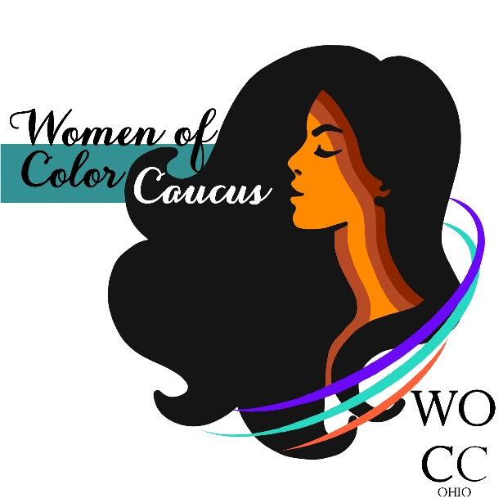  In partnership with the Ohio Domestic Violence Network & Ohio Alliance to End Sexual Violence
Our Mission  The Ohio WOCC is a group of diverse women concerned about the violence against women of color. We are committed to developing leadership in women, community education, and efforts that will influence policy and systems to more effectively respond to improving the lives of all women.  Our Vision  The Ohio WOCC shall be known as a truly diverse’ women of color caucus- made of many cultures and ethnic groups (We define women of color broadly to include any woman that lives as a member of an oppressed group based on race, culture, and/or ethnicity on a daily basis.) We are recognized as a national best practice model for caucusing based on our ability to be a powerful group involved in the community with a clear voice that influences and changes policy.  Our Values  - Ethical Communication  - Mutual respect  - Safe spaces for women of color  - Community trust  - Support and problem solving  - Appreciation for the whole person | WOCC Benefits  Becoming a member of the WOCC offers you the opportunity to socialize, enjoy peer support and receive professional development information in a safe and supportive environment.  We value our members as our greatest asset and promote the personal and professional wellbeing of each individual. We believe that the WOCC has the potential to become an integral part in the lives of all our members.  The Women of Color Caucus is committed to the professional advancement of our members and through our statewide listserv: mailto:odvnwocc@yahoogroups.com  members have access to:  ◊ Networking Opportunities & Social Events  ◊ Ongoing Support from other Women of Color  ◊ Updates on Conferences and Trainings  ◊ Employment Opportunities  ◊ Skill Building and Professional Development | WOCC Meetings & Events  Annually the WOCC holds a Women of Color Institute/Retreat event that focuses on issues and topics specifically related to the unique challenges faced by women of color. Future information on this event will be posted on the WOCC listserv.  2021 WOCC Meetings 10-3:  March 5th  May 21st  August 5th & 6Th (Leadership Summit)  November 5th  WOCC Co-Chairs:  Rosa Beltré  Executive Director  Ohio Alliance to End Sexual Violence  Phone: 216-658-1381 ext.202  Email: rbeltre@oaesv.org  Alicia Williamson, MSW LSW  Director of Training  Ohio Domestic Violence Network  Phone: 614-781-9651  Email: aliciaw@odvn.org

